HTML5 and CSS3 assignment:

Create a web page with HTML5 and CSS3:
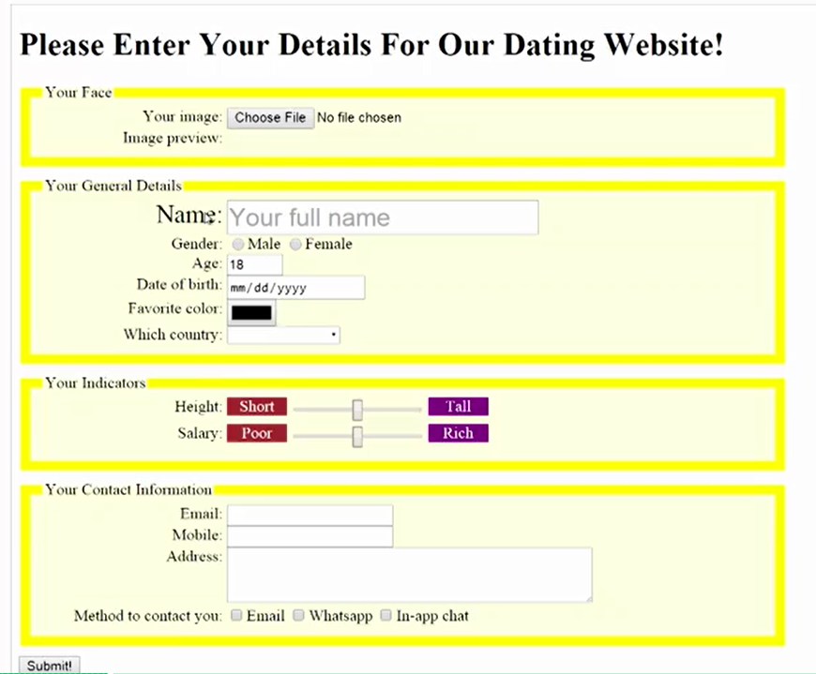

Requirement:
Create four groups. These all field set with legend.
Group example:
<form>
<fieldset>
<legend>Personal Information</legend>
First name? <input type="text" name="firstName"> <br>
Last name? <input type="text" name="lastName"> <br>
</fieldset> <br>
<fieldset>
<legend>Favourite Things</legend>
Favourite cartoon? <input type="text" name="favCartoon"> <br>
Favourite pizza? <input type="text" name="lastName"> <br>
</fieldset> <br>
</form>
- Your face section:
  - Handling file upload: <input type=”file”>, you should be able to preview the uploaded image on the web page.
  - Same as uploading a image, upload audio and video on the page (Bonus points)
- Your General details:
  - Show “your full name” in the textbox as the tooltip
  - Gender
  - For Age, use a number input field as a spinner which you have up and down arrow at the right of the textbox to increase or decrease the number value (Hint: input type: Numbers)
  - For Date of birth field, see below: (Hint: input type: Date)
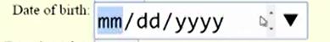
  - Favorite color: click on the color box, it should show the color picker on the page.
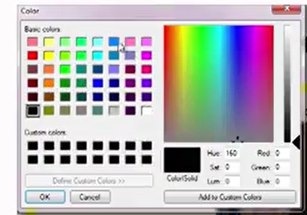
  - Which county: it will show a list of countries in the drop down. You can hardcode some values. (hint: input Attr datalist)
- Your indicators:
  - Height and Salary should be sliders. (Hint: input type Range)
- Your contact information:
  - It should have Email, Phone and Address
  - Method to contact to you.
- Validation requirement:
  - Make all the input fields as required fields. (Hint: input Attr: Required)
  - While typing in the email input, validate if it is a valid email address. (Hint: Input type: Email)
  - While typing in Phone input, only numbers are allowed (Hint: Input type: Phone)
- Style requirement:
  - For each group, highlight the border and make the background color to light yellow.
  - If you mouse over the labels or the input controls, they will get larger. (see “Name” and name textbox in the screenshot above)
  - Be creative, create your own style and make the web page look great! (Bonus points)

